
iCerMax™ 1” Water indicator and particle filter
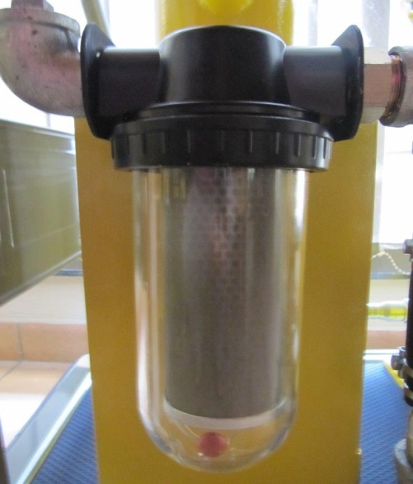
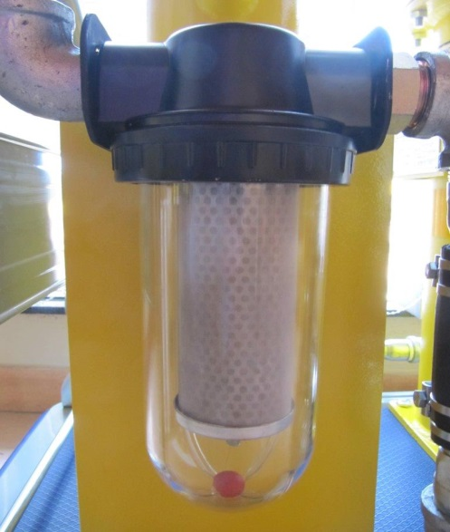
iCerMax™ 1” Diesel filter iCerMax™ 1” Strainer

-Multi pleated particle filter - 30 micron
-Water indicator and removes water (Suspended and free water) - flow rate dependant

Applications:
-Mobile Trailers
-Famers Gravity tanks
-Filling Gensec tanks on receiving
-inline Strainers
-Small kerbside pumps

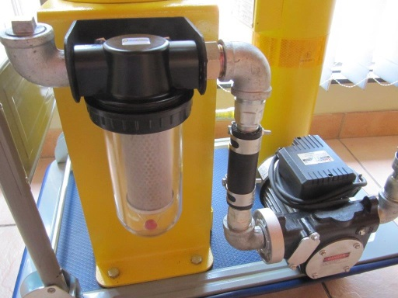

Use as inline Strainer to protect pumps, especially at tank cleaning:
-1” flow, no internal reduction on flow, no cavitation on pump, especially fitted on suction side,
other products reduce to 14 mm inside, cause cavitation on pump
- Clear bowl visible
- Red ball water indicator
- Metal strainer reusable - 150 micron

